How are you feeling?
Remember – no feeling lasts forever, the bad feelings can and will go away.

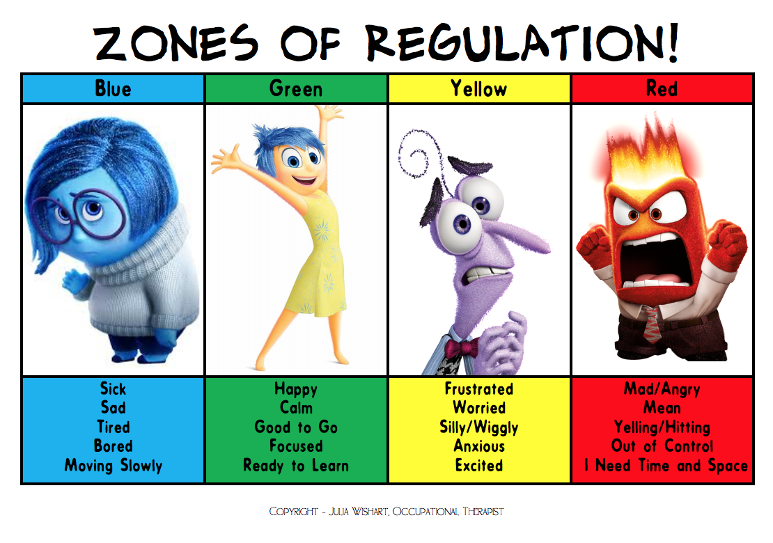
When we are happy and relaxed, our body works fine. But when our brain thinks we are in danger, it sends messages all over our body to get ready to run away from the danger , fight and be ready to meet the danger or freeze, which means we get stuck to the spot. This is a good thing when we want to hide!
Watch the clip ‘Flight, Fright, Freeze’, to find out more.

https://www.youtube.com/watch?v=FfSbWc3O_5M

Tick all the feelings you have had over the last week. Which zones have you been in?
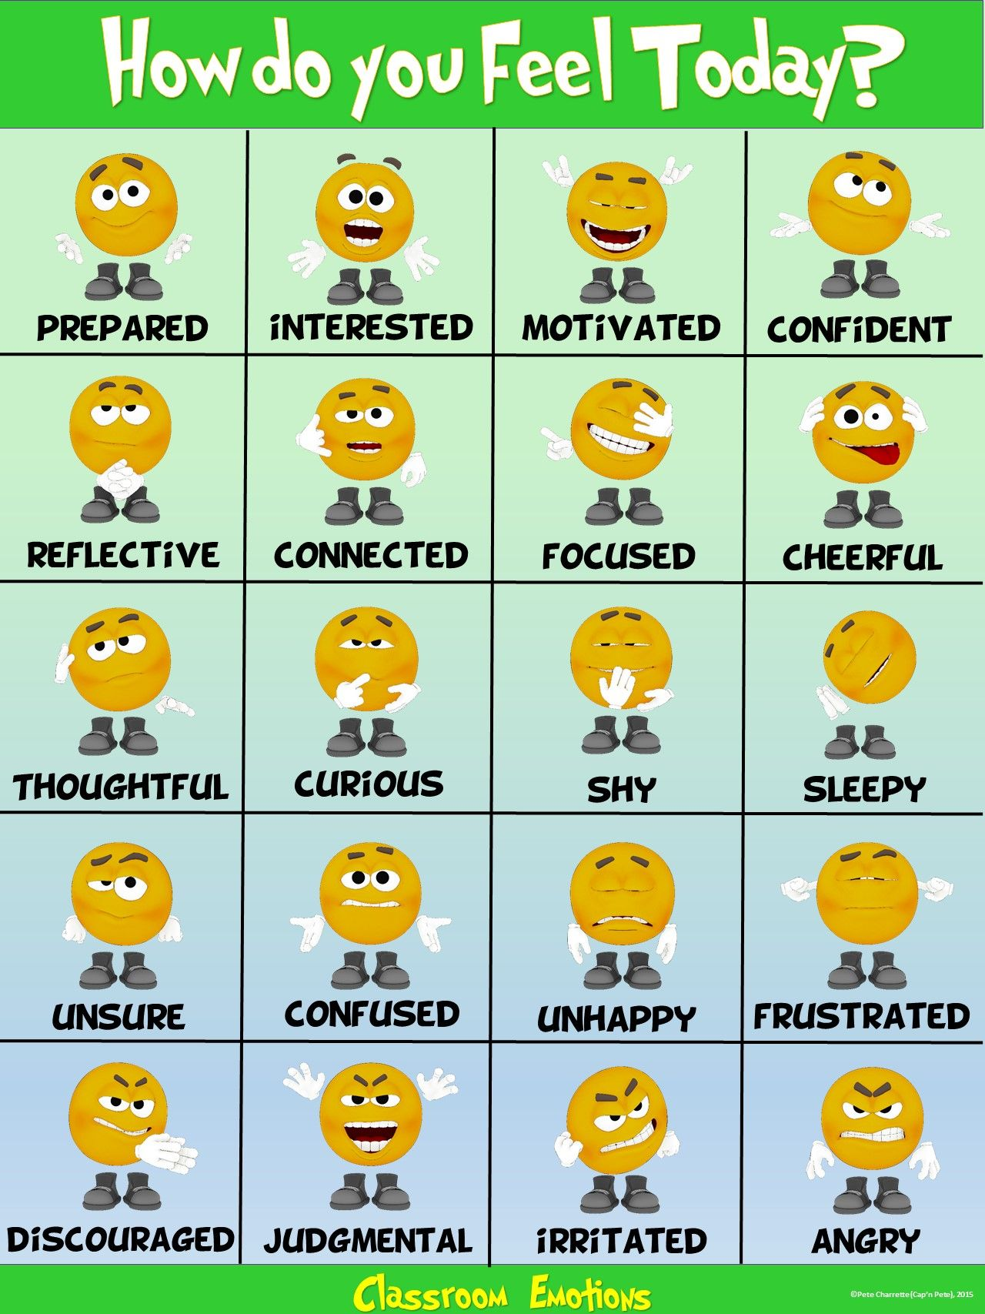
.

Remember: Your feelings are perfectly normal, but understanding how we are feeling can make things seem less scary.

Have a look at the Blob Tree. Which one do you think you are and why?

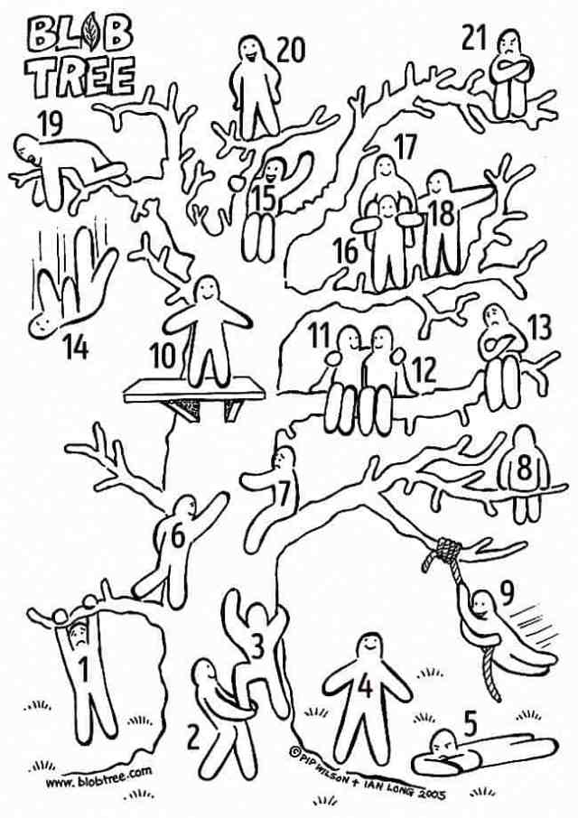

UNCERTAINTY

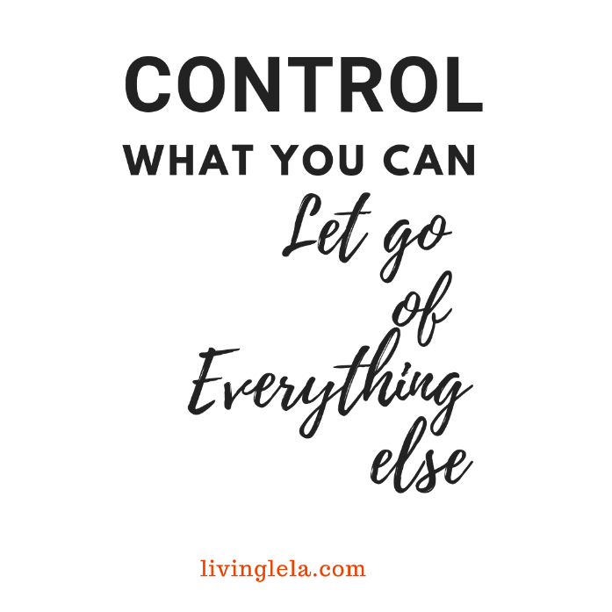
There are so many things we can’t control, which can be tough to accept but the best thing to do is concentrate on the things you CAN control.

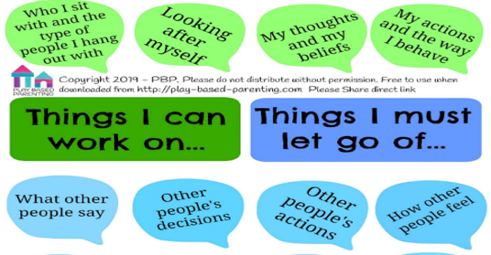
Write down the things you can control and the things you need to let go of.

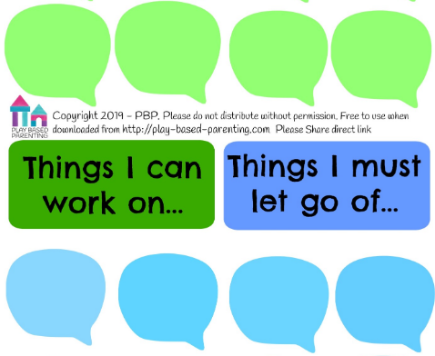
FEELING LONELY
You might feel lonely being inside by yourself. Write down people who care about you and are in your circle.

When we feel uncomfortable, we usually try to find things that make us feel better. You may have tried some of these in class already.

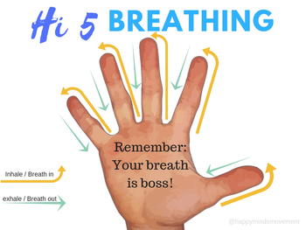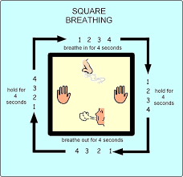

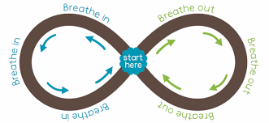
WHALE BREATH 
Take a deep breath in, hold it while you count to 5 with your fingers then tilt head up to blow it out of your blowhole. You can also put your hands up on top of your head to create the blow hole to “blow” out.

RAINBOW BREATHING 
Arms start at the side of your body; arms go up as you breathe in and go down as you breathe out (arms make a rainbow).
OTHER ACTIVITIES TO TRY
- How many things can you see which are square, circles or rectangles etc..?

- How many things can you see which are blue, green or brown..?

- Think of a word to match every letter of the alphabet. Here are some example categories, but you might have others you can think of:

Types of animals
Things you like to eat
Places
Names

Imagine a happy place

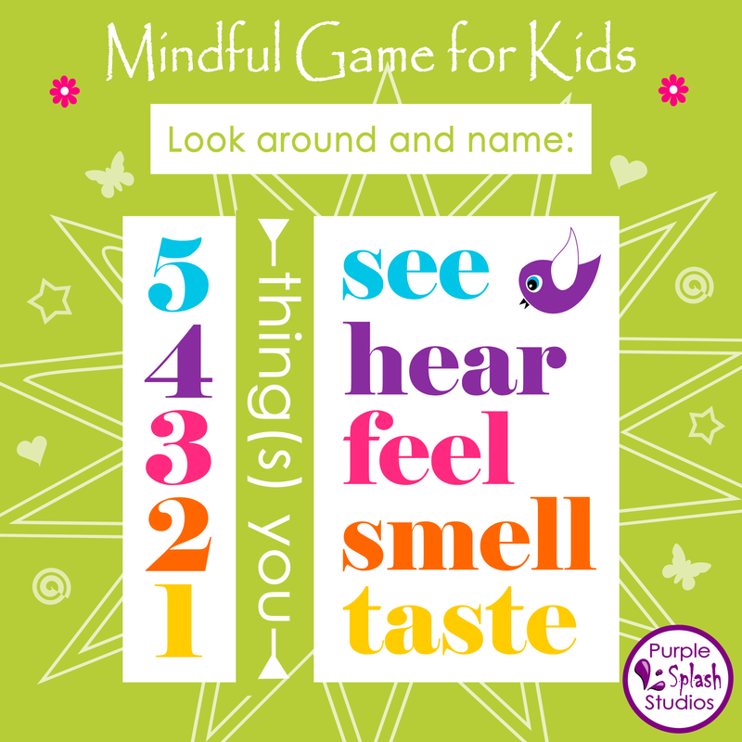

WORRY MOLES

Worries pop into our heads all the time. Everybody worries about things nearly every day.

Write down any worries you have had this week. Out of 10, how much do you believe them to be true?

Not at all A little bit Quite a bit A lot
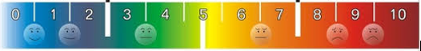

Be Kind to Yourself

Write down some ideas about how you can be kind to yourself. Some ideas have been given to start you off. How can you make these happen, or who would you need to help?

Relax

Be Brave

Laugh

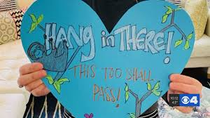
Do something new

Breathing

Gratitude Jar
Every day write down something you are grateful for.


OPTICAL ILLUSIONS
When we concentrate on what we are doing and what is around us, it can help us feel less worried about what might happen. Try some of the activities on the next few pages.

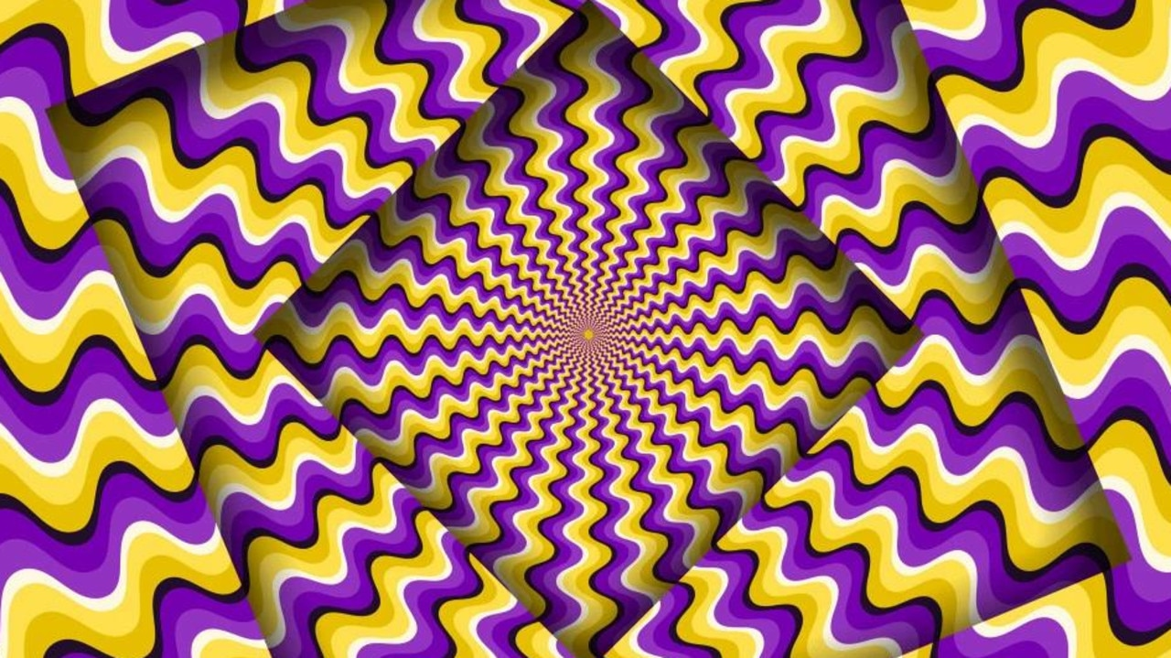
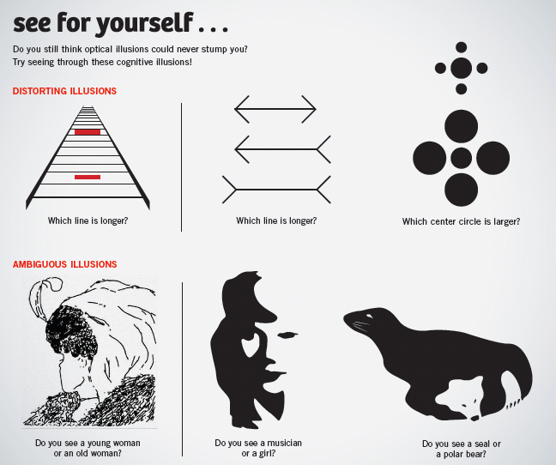


Have a go at drawing your own optical illusion
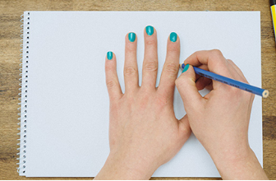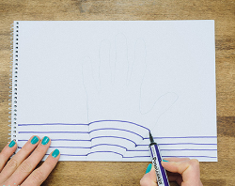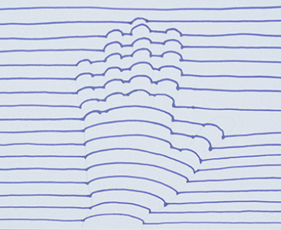

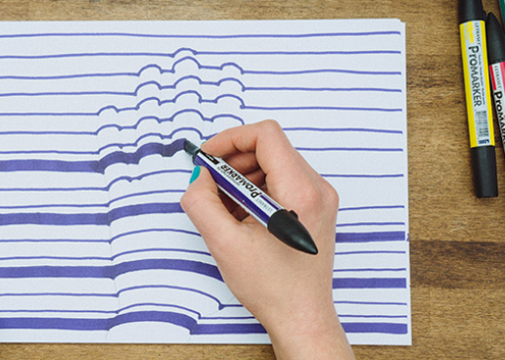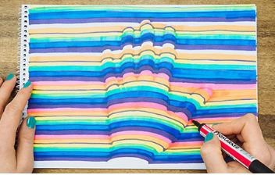
Use 3 different colours and always repeat the same order of colours.
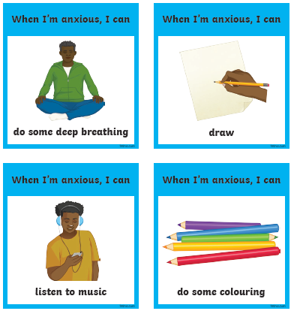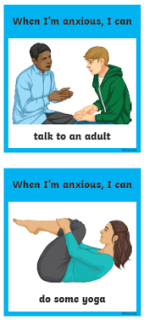
Choose a pencil (or coin) and look at it.

Notice the colour.
Does it have any marks?
How long is it?
What shape is it?
How sharp is it?.
Is it smooth?

Now put it in the middle of the table with other peoples’ pencils.
Mix them up.

Which one belongs to you?

Try this with different objects.


