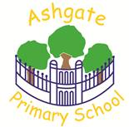
Ashgate Primary School
Ashbourne Road
Derby
DE22 3FS
Telephone: 01332 343928
E mail: admin@ashgate.derby.sch.uk

28th September 2026
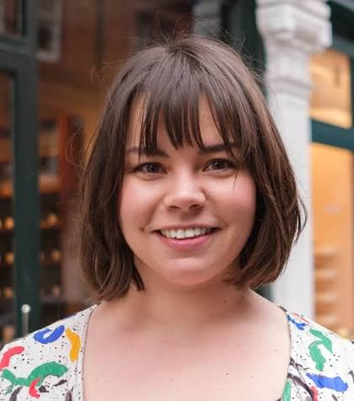
Meet the Author: Alice Harman

We have a really exciting day coming up on Monday 19th October!

Alice Harman is a children’s author who lives in Derbyshire and is proudly ADHD. She will be delivering an assembly about one of her newest books called Your Wild and Wonderful Brain. Then she will run creative workshops based on other books for our pupils in years 1-6! There will be plenty of time for children to ask questions about being an author too.

Alice says: “I help kids to explore our world and its wonders by writing and developing books that make big ideas feel exciting and easy to understand. I’ve written more than 50 books and I’m always just as excited to get started on the next one – partly because it’s a great way to add to my author stash of bizarre facts. Did you know that gorillas burp when they’re happy? Or that art used to be an Olympic event?”

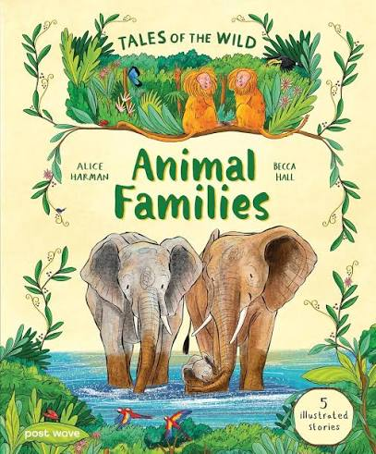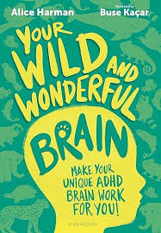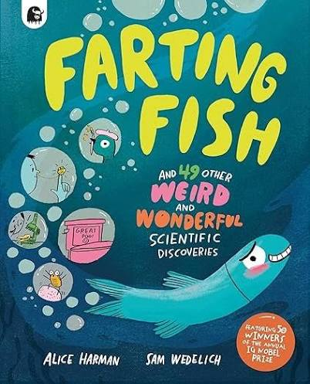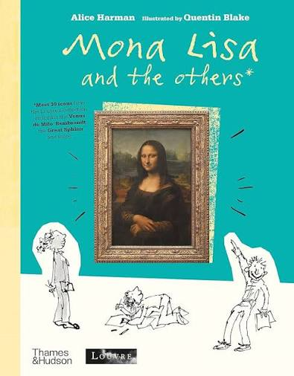

To fund Alice’s visit and so that school can purchase copies of her books for the library, we are requesting a donation of £2.00 per child. This is now set up on Scopay.

If you would like your child to take home one of Alice’s books on the day, there are two ways to do it:

- Alice will be selling books on the playground/in the hall at the end of the day. She will have a card reader available.
- You can pre-order signed copies of Alice’s books on this special part of her website - www.aliceharman.com/signed-books - which she will then bring along on the day. The deadline for these orders is Friday 16th October.

We are really looking forward to welcoming Alice to Ashgate for such an inspiring, fun, creative day!

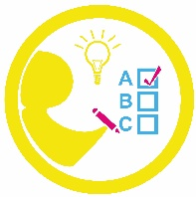
your self your future your learning

